VISVESVARAYA TECHNOLOGICAL UNIVERSITY
“JNANA SANGAMA” BELGAUM-590018

2017-2018
A
Mini Project Report
On

Cyber Cafe Management
Submitted in partial fulfillment of the requirements in 5th Semester of
BACHELOR OF ENGINEERING
IN

By
Gaurav Sharma
[1JB15CS051]

UNDER THE GUIDANCE OF

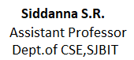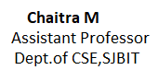



DEPARTMENT OF COMPUTER SCIENCE AND ENGINEERING

S. J. B INSTITUTE OF TECHNOLOGY
B G S HEALTH AND EDUCATION CITY
Kengeri, Bengaluru-560060.

|| Jai Sri Gurudev ||
Sri Adichunchanagiri Shikshana Trust ®

S. J. B INSTITUTE OF TECHNOLOGY

BGS Health & Education City, Kengeri, Bengaluru-560060.

DEPARTMENT OF COMPUTER SCIENCE AND ENGINEERING

CERTIFICATE

Certified that the mini project work entitled “Cyber Cafe Maagement” carried out by Gaurav Sharma [1JB15CS051] is a bonafide student of S J B Institute of Technology in partial fulfillment for the award of “BACHELOR OF ENGINEERING” in COMPUTER SCIENCE AND ENGINEERING as prescribed by VISVESVARAYA TECHNOLOGICAL UNIVERSITY, BELGAUM during the academic year 2017-2018. It is certified that all corrections/suggestions indicated for internal assessment have been incorporated in the report deposited in the departmental library. The mini project report has been approved as it satisfies the academic requirements in respect of mini project work.

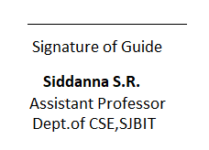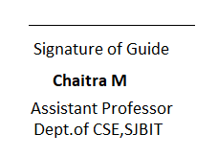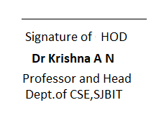
EXTERNAL VIVA
Name of the Examiners Signature with Date

1.

2.


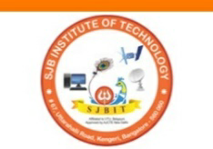
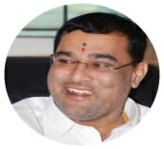

ACKNOWLEDGEMENT

I would like to express our profound gratefulness to His Divine Soul Jagadguru Padmabhushan Sri Sri Sri Dr. Balagangadharanatha Maha Swamiji and His Holiness Jagadguru Sri Sri Sri Dr. Nirmalanandanatha Maha Swamiji for providing us an opportunity to complete our academics in this esteemed Institution.

I would like to express my profound thanks to Reverend Sri Sri Prakashnath Swamiji, Managing Director, SJB Institute of Technology, for his continuous support in providing amenities to carry out this project in this admired institution.

I express my gratitude to Dr. Puttaraju, Principal, SJB Institute of Technology, for providing me excellent facilities and academic ambience, which have helped me in the satisfactory completion of the mini project work.

I extend my sincere thanks to Dr. Krishna A N, Professor and Head of the Department of Computer Science and Engineering, SJB Institute of Technology, for providing me invaluable support throughout the period of my mini project work.

I express my deepest gratitude and sincere thanks to mini project guides Chaitra M, Associate Professor, and Sidanna S R , Assistant Professor, Department of Computer Science and Engineering, SJB Institute of Technology, Bengaluru, for their valuable guidance and support.

Finally, I take this opportunity to extend my earnest gratitude and respect to my parents, the teaching & non-teaching staff of the department, the library staff and all my friends, who have directly or indirectly supported me during the period of my mini project work.
Regards,
Gaurav Sharma
[1JB15CS051]

Abstract

Cyber Cafe Management System can be used by Cyber Cafes to maintain the records of Members coming at Cyber Cafe easily. It provides a good interface for members and employees to connect . Achieving this objective is difficult using a manual system as the information is scattered, can be redundant and collecting relevant information may be very time consuming. All these problems are solved using this project.

